*May Monthly Special:
10% OFF
All Cardstock
Stickers
&
Open Stock
Papers!
- Now through May 31st
- Promo Code SCR514
*Stock Report:
We are discontinuing PP-0016E Hunting. Please sub the updated PP-0030E Hunting.
PUZZLE PP-0041E is very low in stock, will be reordered and back in stock soon.

Paper Crafting News
Stories from the Field:
Meet the Paper House Inside Sales Team
(left to right: Carol Wase, Sondra Keesler & Guy Reed)
You have been talking to them for years, get to know a little bit about them.
Carol Wase: I have just celebrated my three year anniversary with Paper House Productions!!! I grew up here in Saugerties and now reside in Catskill New York with my husband and two daughters.
Sondra Keesler: I’ve been with Paper House for 6 ½ years. I’m a card maker, a cat and squirrel lover, and I love corny jokes.
Guy Reed: Originally from Minnesota, I’ve lived for 17 years in the Catskill Mountains with my wife and two children. I’ve worked at Paper House Productions for 14 years.
Call us anytime with any questions you may have. We are here to help!
Phone: 800.255.7316 Fax: 800.679.8976
Carol Ext. 125 Sondra Ext. 124 Guy Ext. 107

This Months Featured items Cardstock Stickers & Open Stock Paper
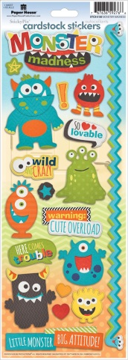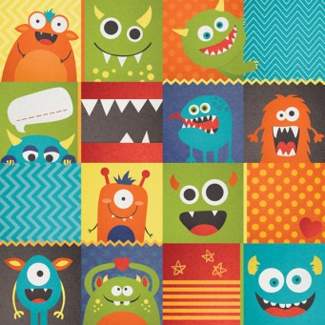
• many designs • great value • awesome themes • must have for every store

Where We Will Be:
July 29-31 • Hilton • Atlanta July 22-24 • Sheraton Hotel July 21-24 • Hilton Garden Booth # 315 Salt Lake City • Utah Salt Lake City • Utah
Booth # 98 afternoon presentation
Project Ideas:
Hey! Do your stores do crops or events? Make it a Paper House Crop, do a Facebook share, post pictures of your crop, store shots etc… and receive 20% off all crop supplies!
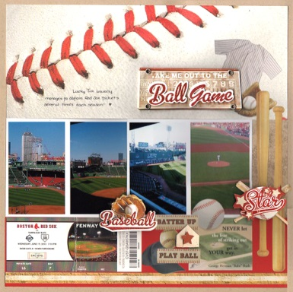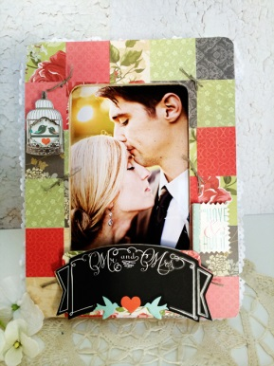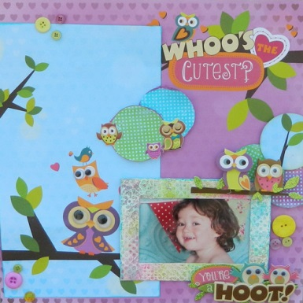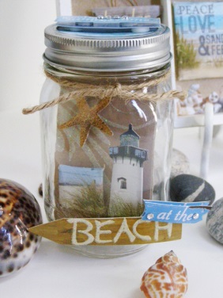

We have tons of project ideas. Go to: http://www.paperhouseproductions.com/community/

